🔵 What is Jitsi?
Jitsi is an open-source video & audio calling platform built on WebRTC.
In simple words:
Jitsi lets you add free audio/video calls into your app — but YOU control and host it.
Unlike Agora/Twilio:
- Jitsi is not a paid cloud SDK by default
- You can self-host it on your own server
- No per-minute calling charges

🧠 What Jitsi Is Commonly Used For
- Online classes
- Community video meetings
- Internal company calls
- Privacy-focused platforms
- Budget-conscious startups
Many education platforms start with Jitsi.

🧩 Jitsi Architecture (How It Works)
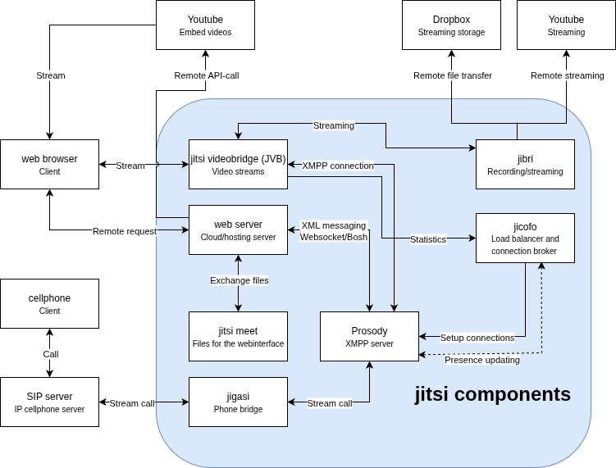
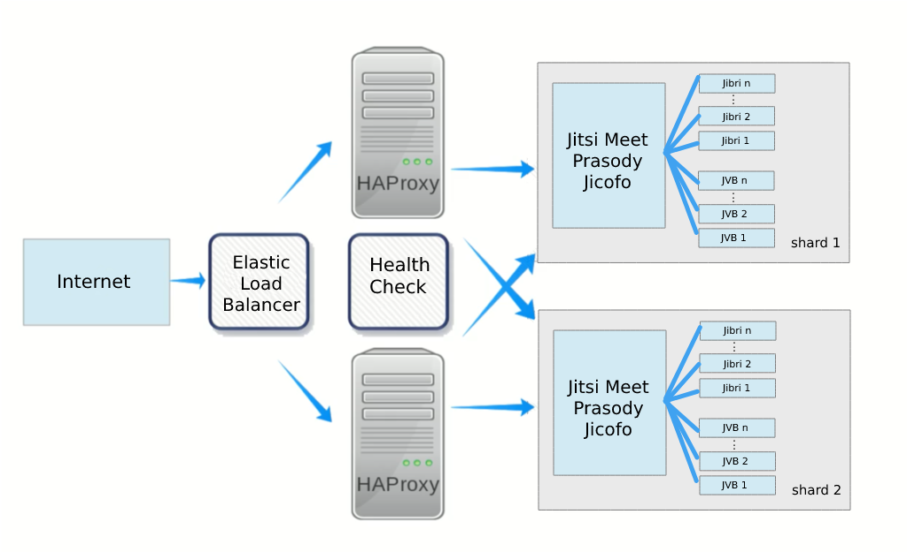
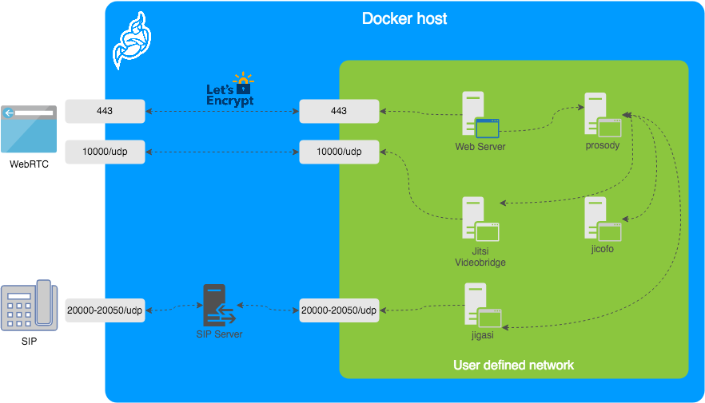
Core Components (Important)
1️⃣ Jitsi Meet
- Frontend UI (what users see)
2️⃣ Jitsi Videobridge (JVB)
- Handles audio/video routing
- NOT peer-to-peer for groups
3️⃣ Prosody (XMPP Server)
- Manages rooms, users, signaling
4️⃣ Jicofo
- Conference controller
👉 When you self-host, you run all of these.

🔄 Call Flow (Student ↔ Mentor)
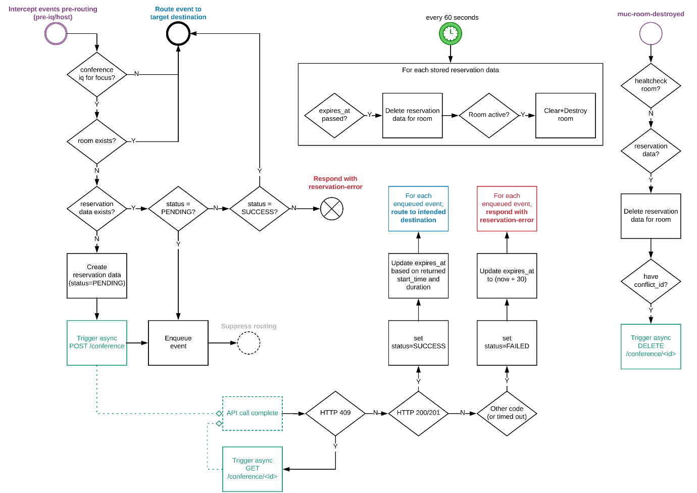
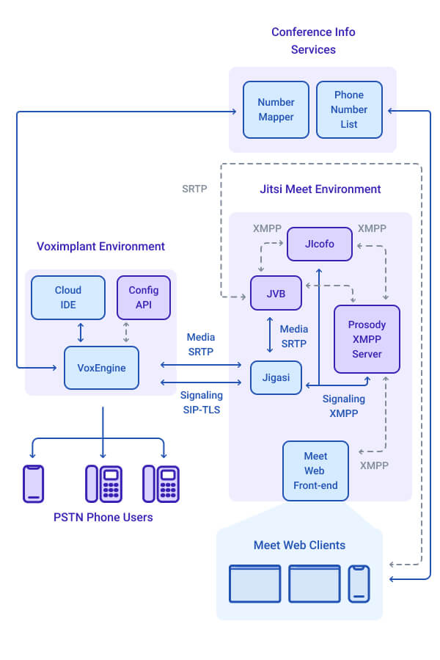
- Student clicks Join Session
- App opens Jitsi meeting room
- Mentor joins same room
- Audio/video flows via Jitsi Videobridge
- Server manages bandwidth & participants
📌 Unlike raw WebRTC P2P, Jitsi always uses a server bridge for multi-user stability.

🆓 Jitsi Meet vs Self-Hosted Jitsi
Option A: Jitsi Meet (Public)
- Uses meet.jit.si
- Completely free
- NOT recommended for production
- No control, no guarantees
Option B: Self-Hosted Jitsi (Recommended)
- Host on AWS / DigitalOcean
- Full control
- Secure
- Custom branding

🔐 Security Model
✔ Encrypted media (DTLS-SRTP)
✔ Room passwords
✔ Moderator control
❌ Not true end-to-end encryption by default (same as most platforms)

💰 COSTING (Very Important)
Jitsi Software Cost
₹0 (Free & Open Source)
Infrastructure Cost (You Pay)
Usage Size | Server Needed | Approx Monthly Cost
1-to-1 calls | 2 vCPU / 4GB RAM | ₹1,500–2,500
Small groups (5–10) | 4 vCPU / 8GB RAM | ₹4,000–6,000
Medium scale | Multiple servers + load balancer | ₹10,000+
📌 Cost depends on:
- Concurrent calls
- Video usage
- Recording (heavy)

🧑‍💻 How Jitsi Integrates Into Your App
1️⃣ Web (Fastest)
<script src="https://meet.jit.si/external_api.js"></script>
Embed meeting in iframe.

2️⃣ Mobile Apps (Flutter / Android / iOS)
- Jitsi SDK available
- Less polished than Agora
- Custom UI is limited
📌 Works well for MVP, not deep UX control.

🎓 Jitsi for Students (Pros & Cons)
✅ PROS
✔ Free (no per-minute fees)
✔ Good for audio-first calls
✔ Open source (privacy)
✔ Works on low bandwidth
✔ No vendor lock-in
❌ CONS
❌ You manage servers
❌ Scaling is manual
❌ UI customization limited
❌ Recording is resource heavy
❌ Less analytics & monitoring

🧠 Jitsi vs Agora (Clear Comparison)
Factor | Jitsi | Agora
Cost | Server cost only | Pay per minute
Setup | Medium | Easy
Scalability | Manual | Automatic
UI Control | Limited | Full
Reliability | Depends on server | Enterprise-grade
Best for | MVP / budget | Production scale

🧭 When SHOULD You Choose Jitsi?
Choose Jitsi if:
- You want lowest running cost
- You have a backend/devops person
- You are building MVP or pilot
- Mostly audio sessions
- Limited concurrent users

🚫 When NOT to Choose Jitsi
Avoid Jitsi if:
- You expect rapid growth
- You want full UI control
- You need analytics & quality monitoring
- You want zero server maintenance
- You plan heavy video usage

🧪 Recommended Strategy (Smart Approach)
Phase 1 (0–6 months)
- Use Jitsi
- Audio-first mentoring
- Validate concept
- Keep cost low
Phase 2 (Scale)
- Migrate to Agora
- Better UX
- Better reliability
- Better scaling
- 🚀 JITSI SERVER SETUP
- We’ll go in this order:
1️⃣ What you need
Item | Recommended
OS | Ubuntu 20.04 LTS
CPU | 2 vCPU
RAM | 4 GB
Storage | 40 GB
Provider | AWS / DigitalOcean / Linode
✅ Domain Name (Mandatory)
You must have a domain, e.g.:
meet.yourjobportal.com
Point it to your server IP using DNS A record.
2️⃣ Server setup

🔹 Login to Server
ssh root@YOUR_SERVER_IP
🔹 Update System
apt update && apt upgrade -y
🔹 Set Hostname
hostnamectl set-hostname meet.yourjobportal.com
Reboot:
reboot
3️⃣ Jitsi installation
Jitsi provides an official installer.

🔹 Step 1: Add Jitsi Repository
curl https://download.jitsi.org/jitsi-key.gpg.key | sudo apt-key add -
echo "deb https://download.jitsi.org stable/" | sudo tee /etc/apt/sources.list.d/jitsi-stable.list
apt update

🔹 Step 2: Install Jitsi Meet
apt install jitsi-meet -y
During installation:
- Enter domain:
👉 meet.yourjobportal.com
- Choose Generate a new self-signed certificate (for now)

4️⃣ Security & domain
Jitsi requires HTTPS for camera/mic access.
🔹 Install Let’s Encrypt SSL
/usr/share/jitsi-meet/scripts/install-letsencrypt-cert.sh
Follow prompts:
- Enter email
- Agree to terms
✅ Now your server has free SSL certificate.

5️⃣ Testing
By default, anyone can create rooms — this is dangerous.
We will make it so:
- Only your backend creates rooms
- Students & mentors can only JOIN

🔹 Edit Prosody Config
nano /etc/prosody/conf.avail/meet.yourjobportal.com.cfg.lua
Change:
authentication = "internal_plain"
Add at bottom:
VirtualHost "guest.meet.yourjobportal.com"
authentication = "anonymous"

🔹 Update Jitsi Config
nano /etc/jitsi/meet/meet.yourjobportal.com-config.js
Set:
anonymousdomain: 'guest.meet.yourjobportal.com',

🔹 Restart Services
systemctl restart prosody
systemctl restart jicofo
systemctl restart jitsi-videobridge2

6️⃣ How your app connects

Only this user can create rooms.
prosodyctl register admin meet.yourjobportal.com STRONG_PASSWORD
This user = your backend identity.

7️⃣ Production best practices
Open browser:
https://meet.yourjobportal.com
- Login using admin credentials
- Create a test meeting
- Join from another device
🎉 If audio/video works → server is ready.

